Log into **Google Chrome**

Go to <http://www.everettsd.org/>

Select A School

Cascade High School

Our School

Attendance Reporting

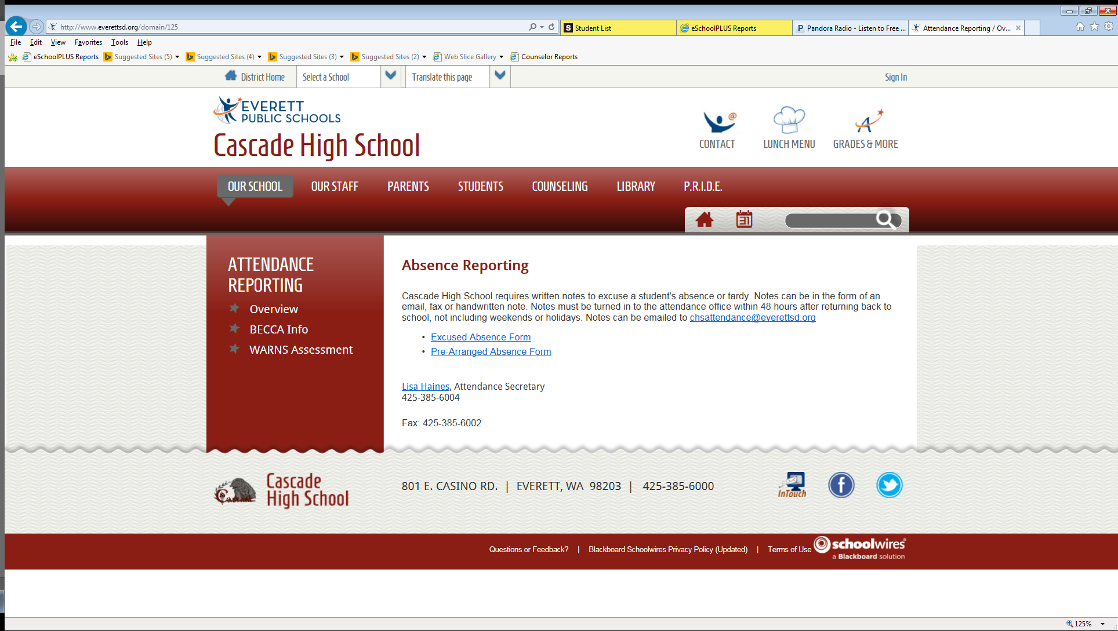

Click on WARNS Assessment on the left-hand side

Click on the blue hyperlink **WARNS Assessment**

Click on the blue here hyperlink.

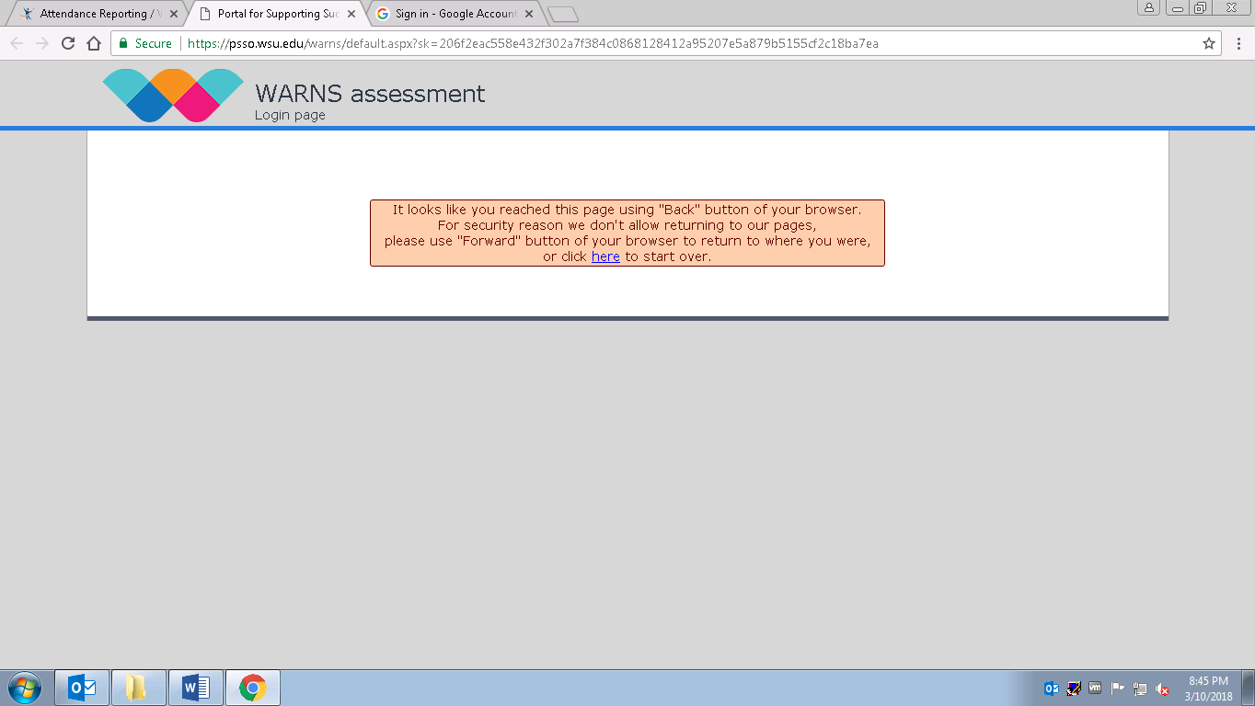

On the next screen, enter email [**warns@everettsd.org**](mailto:warns@everettsd.org), password **Everett,** click on login

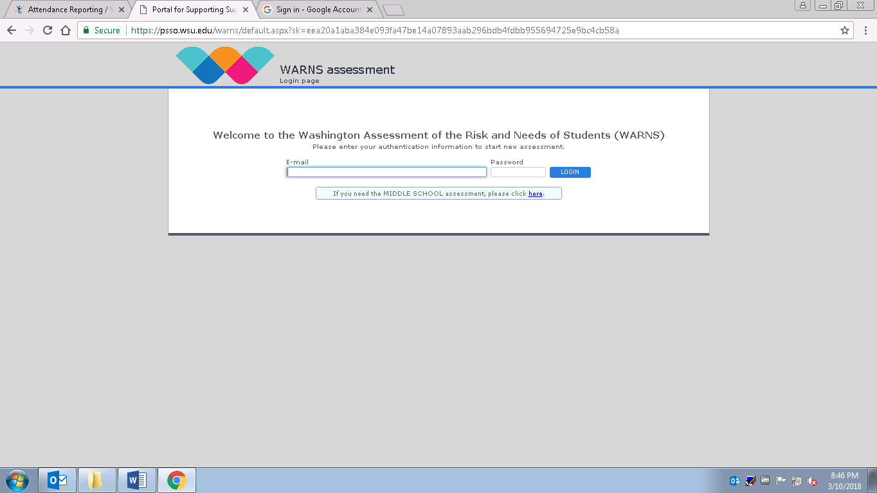

Check the box and click on Next:

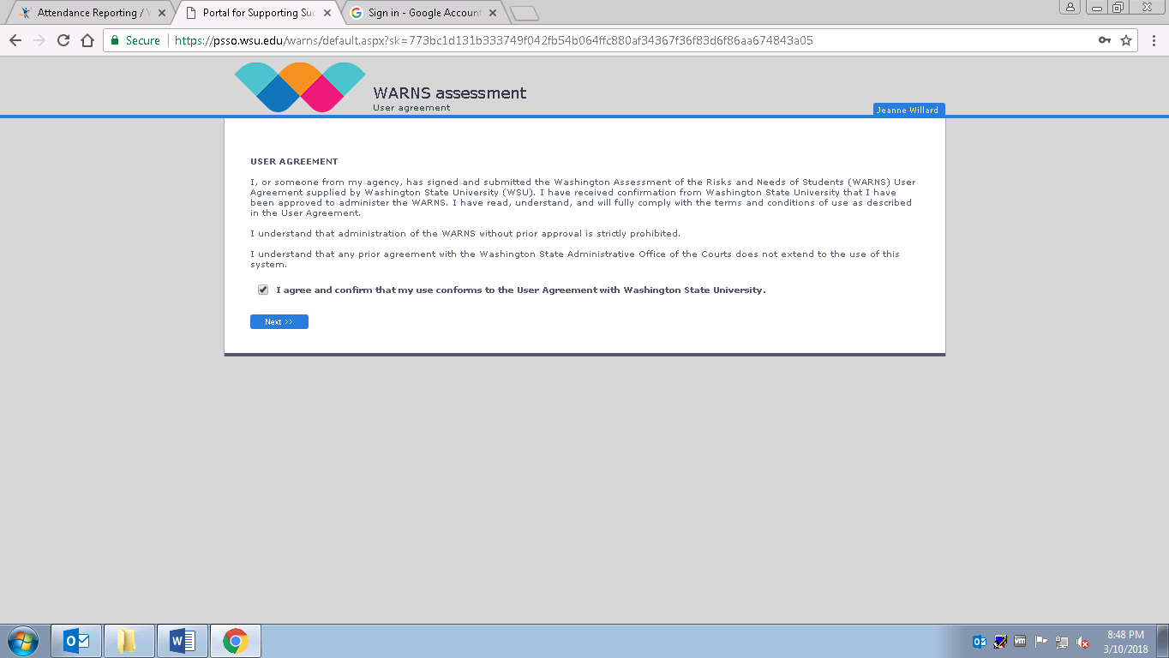

Select *Cascade High School* from the list, then enter your student ID number, then click *Next*

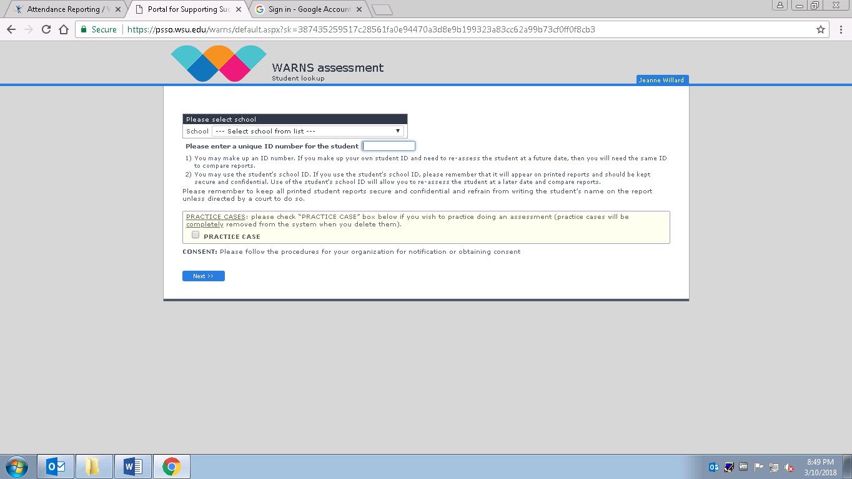

Select ***Full Version*** and click on *Next*

Then click Yes or No to the following 3 questions:

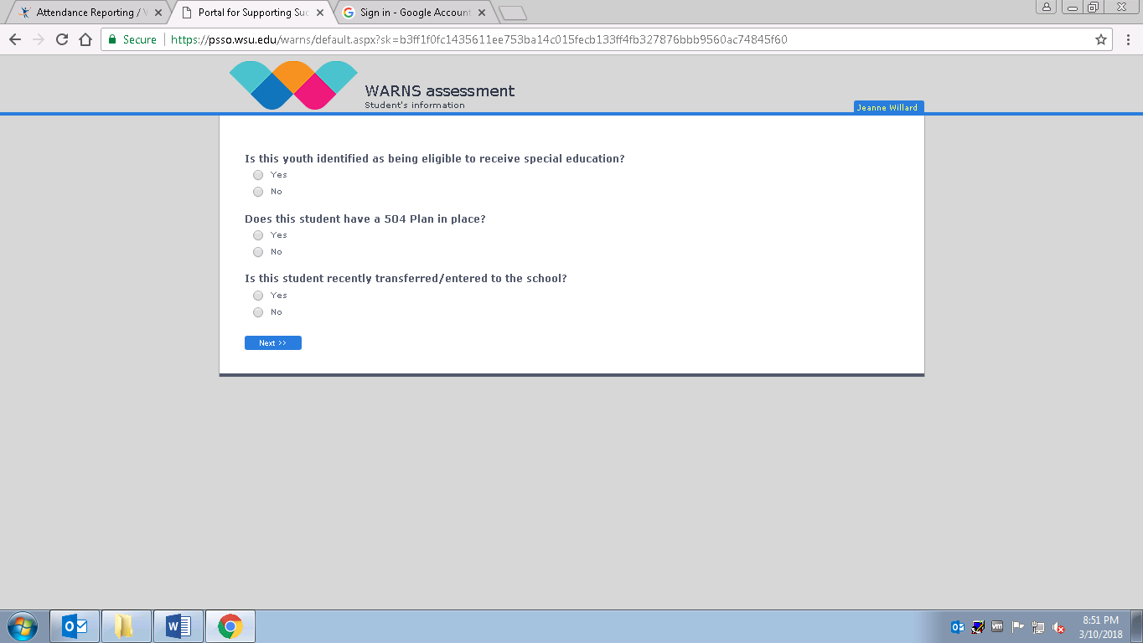

Then click *Next.* There are 35 multiple choice questions.

When you get to question 35, please answer the question and **STOP**. Raise your hand and we will review and save the survey and you will log off and return to class.

**Thank you for your participation!!**